Hugging-face, Github and Jupyterlab version control
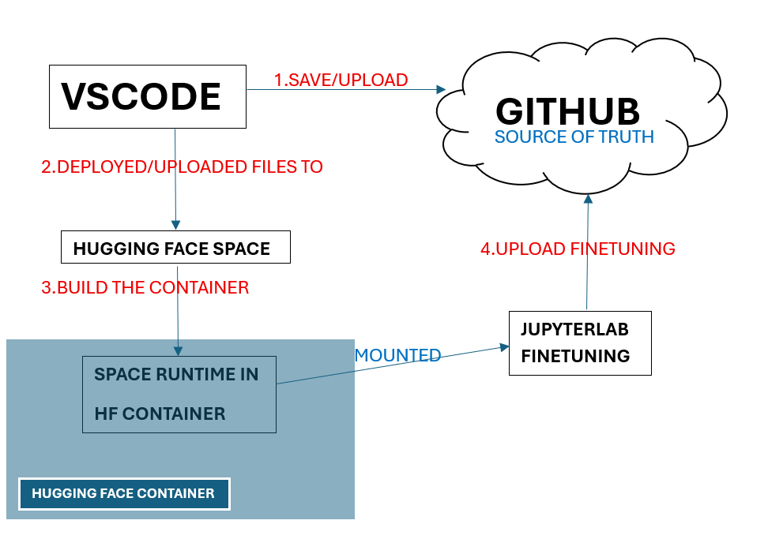
Before using this version control workflow for Hugging Face, it is important to understand the diagram above.
In this workflow, code changes for the Hugging Face Space are always pushed to GitHub before Hugging Face Space. GitHub is treated as the canonical source of truth for version control.
Commits made directly to Hugging Face Space do not automatically synchronise back to GitHub. As a result, changes committed only within Hugging Face Space may be overwritten when the GitHub version is pushed again during subsequent deployments. This can lead to the loss of previously committed files in the Space repository. Therefore, all changes must be committed and pushed to GitHub first to ensure they are safely recorded before deployment to Hugging Face Space.
After all required changes have been pushed to Hugging Face Space, the Space automatically builds a container based on the repository configuration. This container defines the application’s runtime environment. Once the build process is complete, the container is executed as the Space runtime on Hugging Face cloud infrastructure.
Although the application is deployed through Hugging Face Space, the interface presented to the user is a JupyterLab environment. When the Space is running, it launches the application container, which provides access to the JupyterLab interface used for fine-tuning. In this workflow, JupyterLab is operationally connected to the Space runtime, allowing users to interact with the fine-tuning environment through the Space interface.
This relationship is represented in the diagram as a mounted connection, indicating that the Space runtime and JupyterLab are linked at runtime while remaining logically separate components.
Code developed within Hugging Face JupyterLab is c omitted and pushed to GitHub using a separate repository from the Hugging Face Space application.
This separation is intentional. The JupyterLab environment is used for model fine-tuning, which often generates notebooks, models code and many more. Storing these files in a separate repository prevents them from being mixed with Space-specific configuration and deployment code.
By pushing JupyterLab changes directly to GitHub, fine-tuning work remains fully version-controlled while allowing the Hugging Face Space repository to focus exclusively on application deployment. This design reduces repository complexity and minimizes the risk of accidental deployment of experimental code.
Committing in VS Code
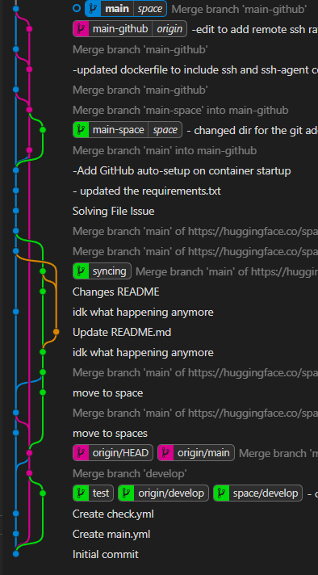 | Understanding the Branch Labels  main-github |origin  - Refers to the main branch on GitHub  - origin is the remote name for the GitHub repository  - When commits are pushed to origin/main, they are visible on GitHub  main | space  - Refers to the main branch on the Hugging Face Space repository  - space is the remote name configured for Hugging Face  - Pushing to space/main deploys the application to Hugging Face Space
The local branch main is shared across both remotes. The difference lies in which remote the commit is pushed to, not the branch name itself.
Commit and Push Workflow in VS Code
- Make changes to the Space application code in VS Code.
- Open the Source Control panel and review modified files.
- Enter a commit message and click Commit.
- Push the commit to GitHub first:
  - This updates origin/main and ensures GitHub remains the canonical source of truth.
- Push the same commit to Hugging Face Space:
  - This updates space/main and triggers the Space container build and deployment.
Pushing at Hugging Face Space JupyterLab
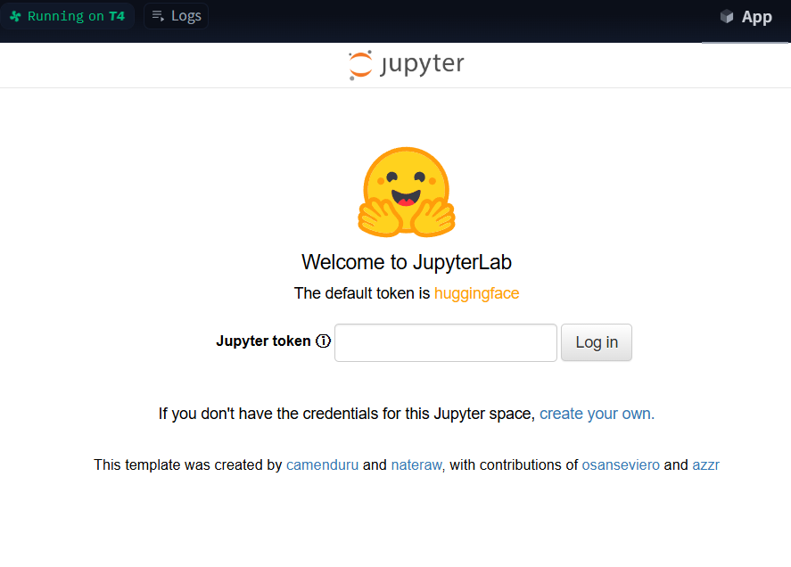


Go to /data path, because all the jupyterlab files is there
You can check using this command
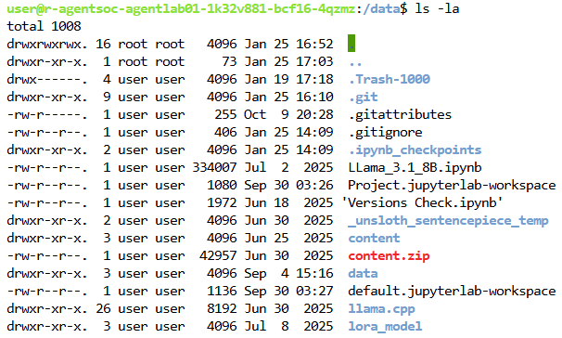
Now you had noticed that there is a .git in /data, that where the repo is.
Now before you start using git, you must create a ssh files.
First check is there any .ssh folder in the /data, you can use this command to find : “ls -la | grep .ssh”
If return nothing, that mean you haven’t created yet.
To create a ssh files, use this command :
mkdir -p /data/.ssh
chmod 700 /data/.ssh
ssh-keygen -t ed25519 -C your_email@example.com
Remember to point to the right directory : / data/.ssh/id_ed25519
Make sure you copy the key and save it.
Now you can identify yourselves with ssh using:
eval $(ssh-agent -s)
ssh-add "/data/.ssh/id_ed25519"
After that call this command:
git config --global --add safe.directory /data
Then now test if the git works or not?
First call, git status
And if success, you will be able to see this:
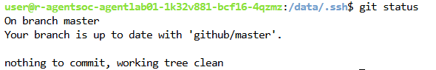
Then call, git remote -v
It all works; you will see this:
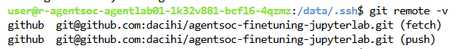
After that, call this command
cat .ssh//id_ed25519.pub
and you will get this output and copy them :
“ssh-ed25519 xxxxxxxxxxxxxxxxxxx you@example.com”
Go to GitHub and click on Settings on your User Profile NOT Repo

You’ll see the SSH and GPG keys, click on it and create a new ssh key. Name it and then paste the ssh key that you just copy.

Now if everything works, you can now make changes to the jupyterlab now.
Example:
I created a files called gittest.txt and I want to commit it.
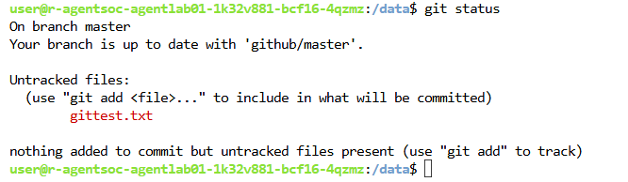
You can use git status to see what is untracked, in staging and what will be committed.

First add everything into the staging area, for me I use
git add -A
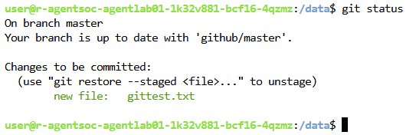
Now if you committed, you might see this error message
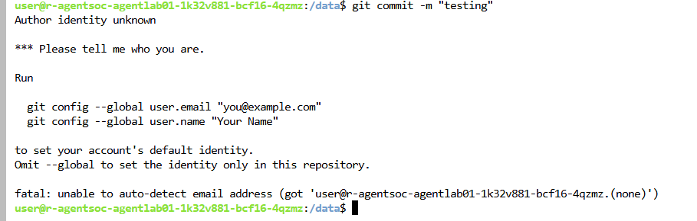
Just run these:
git config --global user.email "you@example.com"
git config --global user.name "Github Username"
To check if the things is inside git config, use this
git config --list | grep user
then you will see this result
Then, you can commit again:
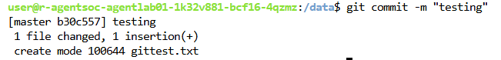
Then push it to the remote,
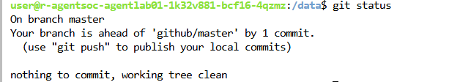
If successful, you will see this 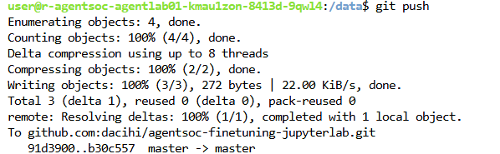
Cannot Start the Hugging Space App?
This may because the Container may be too heavy, do a factory rebuild it at the settings and it will starts normally but it takes a little longer since is rebuilding the container again.


